
FLEXFORM CABLE ENGINEERING
TECHNICAL DATASHEET
© All rights reserved.
All contents of this document are our property and any copy or divulgation is not allowed without our written authorisation.

Braided Double Insulated FEP/FEP Triple Twisted Flex Product Range: BTFF
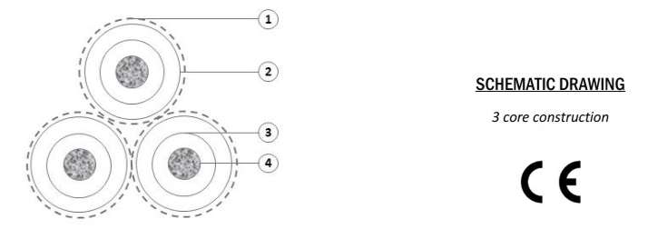
CABLE CONSTRUCTION  1. Viscose Rayon braid  2. R5F type FEP insulation  3. 180 °C transparent FEP outer insulation 3  4. Electrolytic tinned flexible concentric rope copper conductor | APPLICATIONS  This product is designed for use as a pendant drop or table and floor lamps. Approval for rise and fall applications should be confirmed with ourselves prior to adoption.  SCHEMATIC DRAWING  3 core construction  CE
Characteristics
Voltage Rating (U₀/U): | 300 / 500 Vac
Test Voltage: | 2500 V
Temperature Range: | -55 °C ÷ 180 °C
Short-circuit Temperature: | 160 °C
Minimum Bending Radius: | 14 x Overall Diameter

Size Conductor  [mm²] | Conductor Stranding  [Nº x mm] | Electrical Resistance  [Ω/Km]
0.75 | 19 x 0.224 | ≤ 26.7

Flexform Product Code | Size Conductor  [mm²] | Outer Diameter  [mm] | Thickness of Jacket  [mm]
BTFF-403 | 3 x 0.75 | 5.6 ± 0.5 | ≥ 0.60
All versions of this cable can be ordered with a plain or patterned viscose rayon textile braid, available in over 60 colours. Please contact us for a list of available colours.
Cable Standards | Low Voltage European Directive No. 2014/35/UE.
Stranding of Conductor | Electrolytic tinned flexible concentric rope copper conductor.
Inner Insulation  Outer Insultation | R5F type FEP conforming to EN-50363-0 requirements.  R5F type FEP conforming to EN-50363-0 requirements.
Cable Assembly | The cores are braided in viscose rayon before being twisted together.
Core Identification 3 Core: Brown ● Blue ● Green/Yellow ●

Revision Date:  21/07/2026 | Issue No.  1.3 | Page:  2 of 2
In order to improve our products, the information contained in this technical datasheet can be changed without notice. Please check periodically with our office, the date and issue number.
FLEXFORM ☎ +44 028 9079 2155 ✉ info@flexform.co.uk ⌂ www.flexform.co.uk

